Business Intelligence Lab
Unit 1 | Session 2
Experiment 2
Designing and Implementing ETL Processes using Microsoft Power BI

Aim
To design and implement an end-to-end ETL (Extract, Transform, Load) pipeline using Microsoft Power BI's Power Query Editor, enabling the extraction of data from a real-world business dataset, application of transformation logic, and loading of cleansed data into a unified analytical model for reporting and decision-making.

Tools / Software Required
1. Microsoft Power BI Desktop
2. Global Superstore Dataset.xlsx
3. Power Query Editor (Built into Power BI Desktop)
4. DAX (Data Analysis Expressions)
Dataset Source:
Global Superstore Dataset (Kaggle)
https://www.kaggle.com/datasets/apoorvaappz/global-super-store-dataset

Theory
ETL (Extract, Transform, Load) is one of the most important processes in Business Intelligence. It enables organizations to collect data from source systems, transform it into a clean and consistent format, and load it into a centralized environment for analysis.
Extract Phase:
The extraction phase involves collecting data from source systems. In this experiment, data is extracted from the Orders, Returns, and People worksheets available in the Global Superstore dataset.
Transform Phase:
The transformation phase includes data cleaning, handling missing values, correcting data types, creating derived columns, filtering invalid records, and integrating multiple datasets.
Load Phase:
The transformed data is loaded into the Power BI data model where relationships can be established and analytical measures can be created using DAX.
Power Query Editor serves as the ETL engine in Power BI and records each transformation step as an Applied Step, making the workflow transparent and reproducible.

Conduct
Part A: Extract – Connect to Dataset
Step 1: Download the Global Superstore Dataset from Kaggle.
Step 2: Open Power BI Desktop.
Home > Get Data > Excel Workbook
Select Global Superstore Dataset.xlsx]
Step 3: Select the following worksheets:
• Orders
• Returns
• People
Click Transform Data.
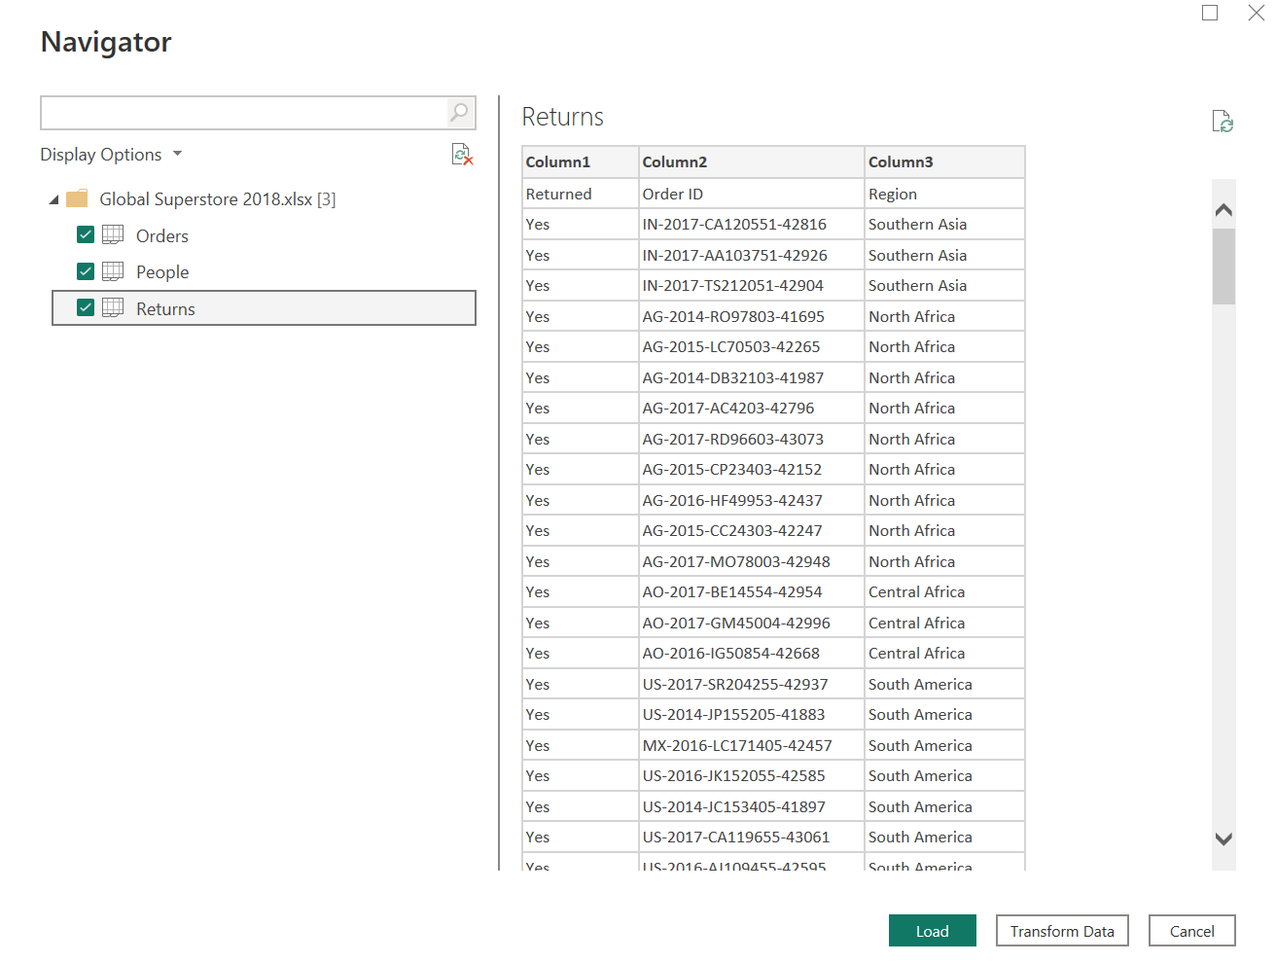
Verify that all imported tables appear in the Queries pane.
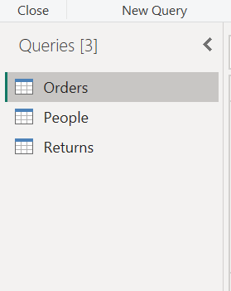

Part B: Transform – Power Query Editor
Step 4: Open Power Query Editor.
Step 5: Apply the following transformations to the Orders table:
• Remove duplicate records
• Remove blank rows
• Verify and correct data types
• Rename columns where required
• Extract Year and Month from Order Date
• Create a custom Profit Margin column
• Standardize Region and Segment values
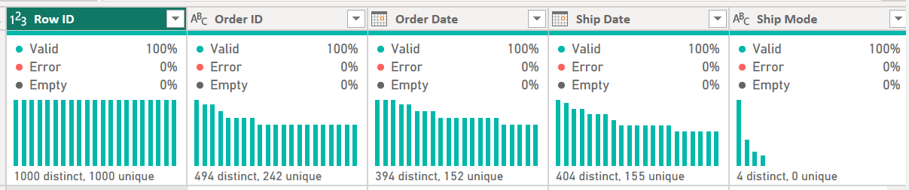
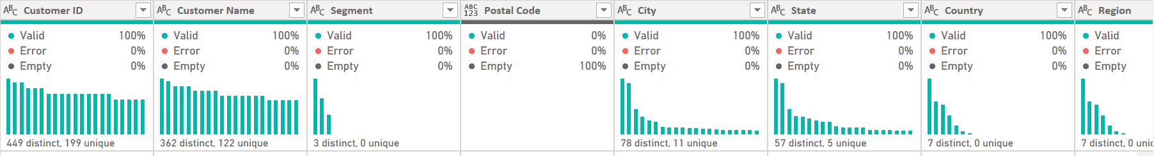
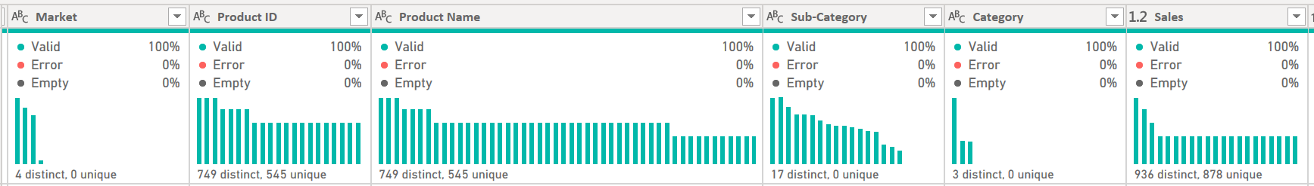
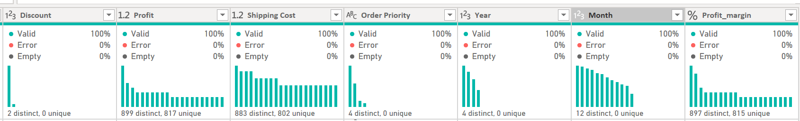
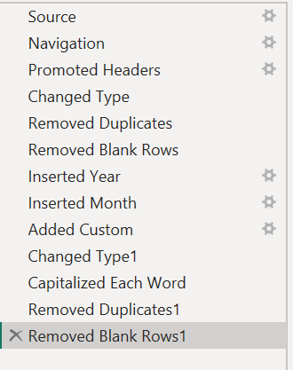
Step 6: Transform the Returns table:
• Remove duplicate Order IDs
• Check for missing values
• Standardize Returned field values.
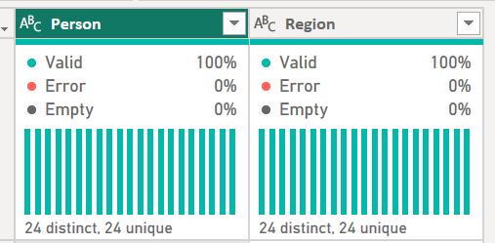 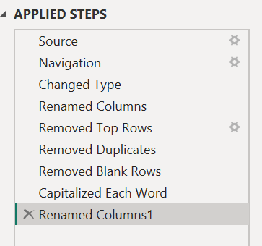
Step 7: Transform the People table:
• Validate regional assignments
• Remove unnecessary columns
• Verify consistency of region names
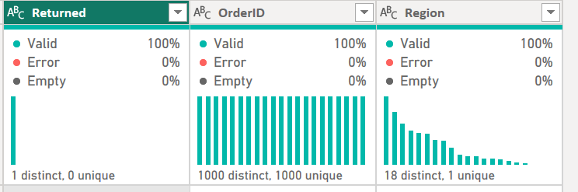 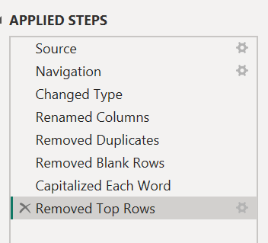
Step 8: Merge Orders and Returns tables using Order ID.
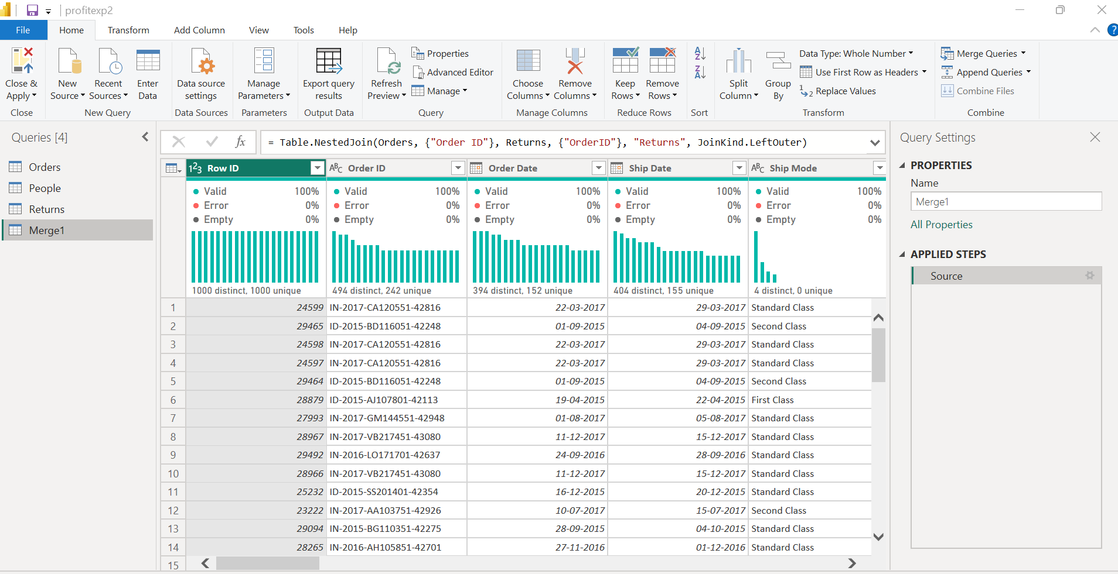
Step 9: Review all Applied Steps and click Close & Apply.

Part C: Load – Build Data Model
Step 10: Navigate to Model View.
Step 11: Create relationships:
Orders ↔ Returns (Order ID)
Orders ↔ People (Region)
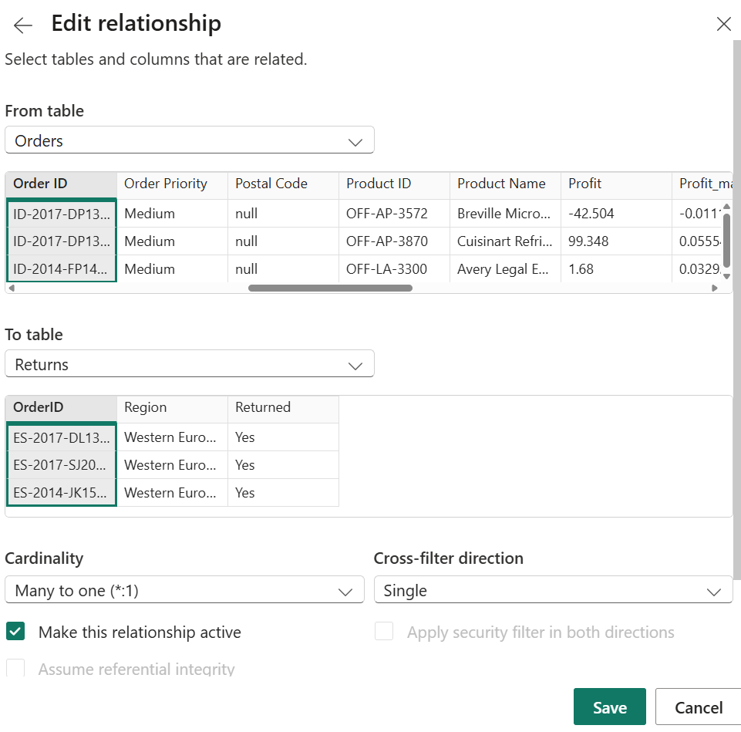
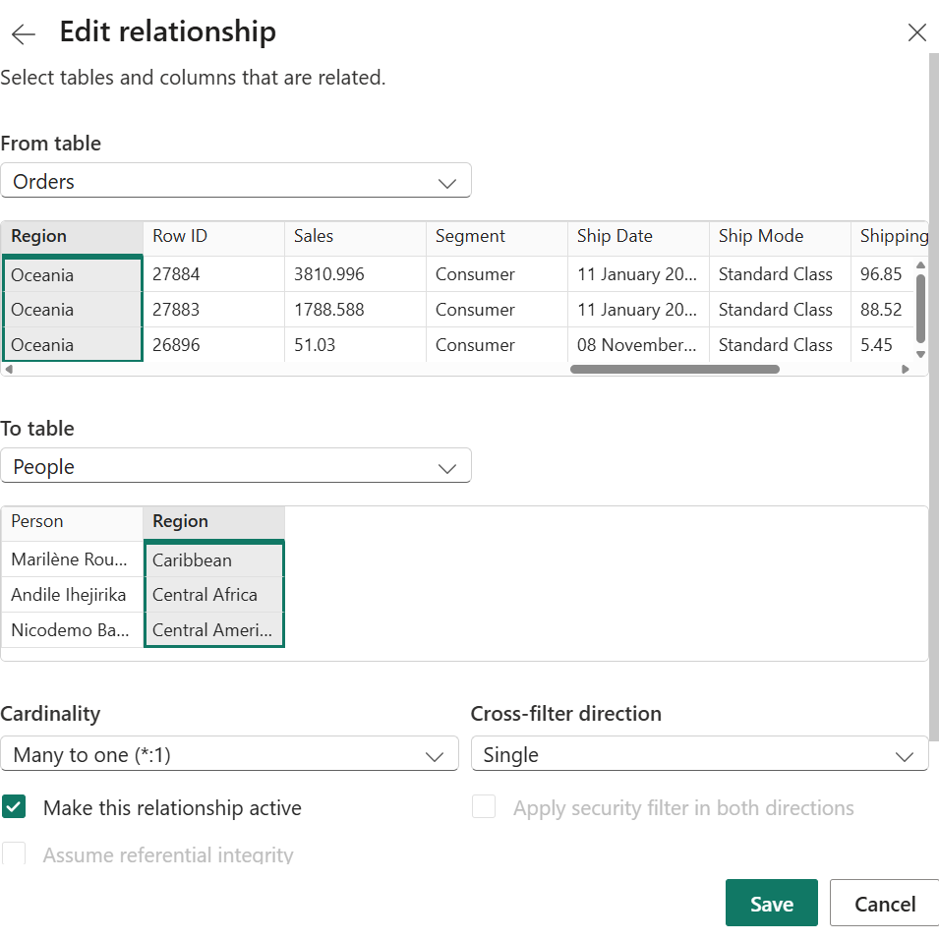
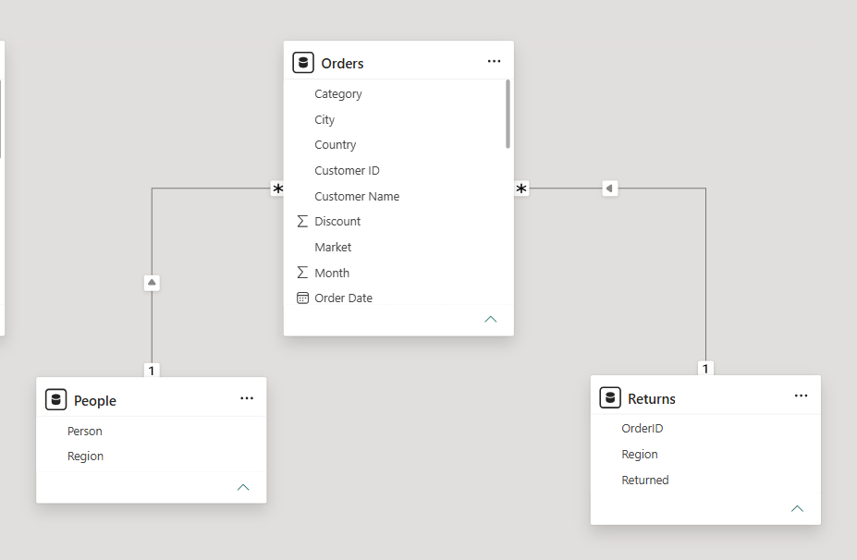
Step 12: Create DAX measures:
Total Sales = SUM(Orders[Sales])
Total Profit = SUM(Orders[Profit])
Profit Margin = DIVIDE(SUM(Orders[Profit]),SUM(Orders[Sales]))
Total Orders = DISTINCTCOUNT(Orders[Order ID])
To do this, go to home tab, under the Calculations pane, select me measure and type the measures
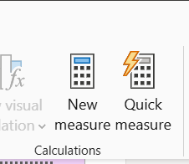
Step 13: Create a simple report visual using fields from related tables.
Dax report
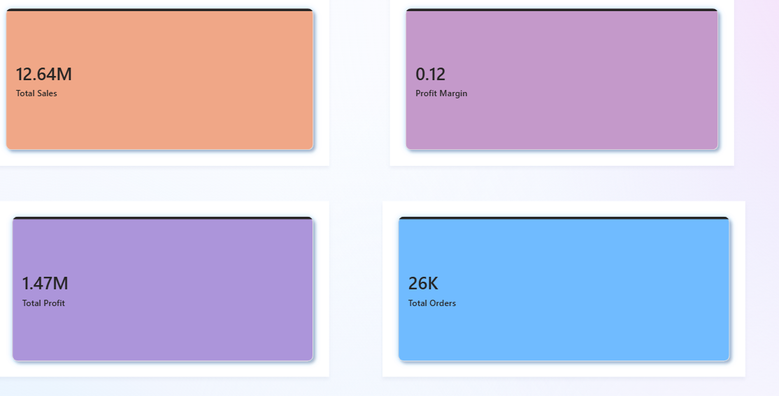

Quantities by person report and quantity by region and returned products report
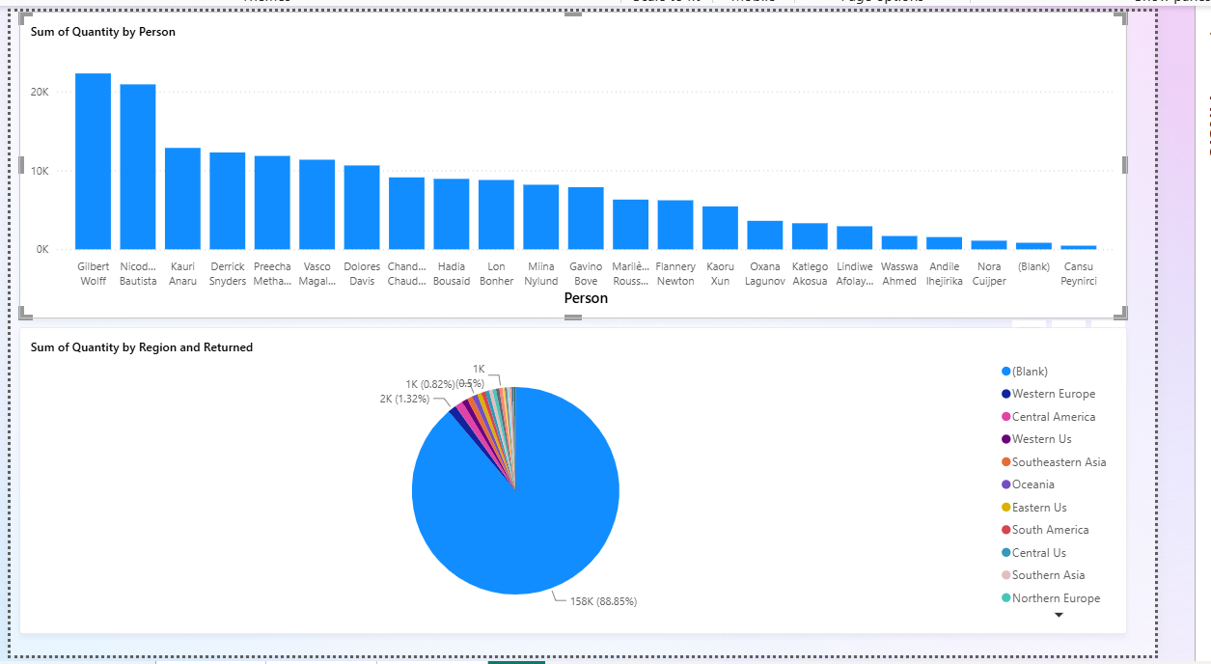
Country, state, region and city dropdown on sales by market and product name
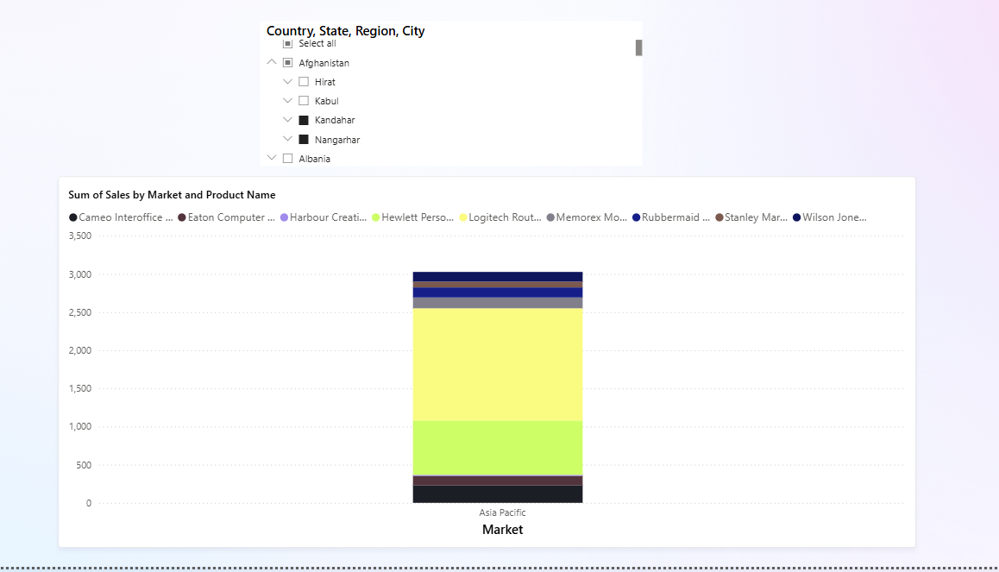

Result
Data was successfully extracted from the Global Superstore dataset, transformed using Power Query Editor, and loaded into the Power BI data model. Data cleaning, standardization, relationship creation, and DAX-based metric generation were performed successfully. The final dataset was prepared for reporting and business analysis.

Learning Outcomes
After completing this experiment, I learned to;
• Explain the ETL process and its role in Business Intelligence systems.
• Extract data from real-world business datasets using Power BI.
• Apply transformation techniques including cleaning, filtering, and merging.
• Create relationships and analytical measures in Power BI.
• Validate transformed datasets for reporting and decision-making.

